**Experian Coffee DB**

This document give the instructions I follow to create and fill the data in a local DB called Experian Coffee from Coffee Quality Institute website.

The folder **ExperianCoffee** contain:

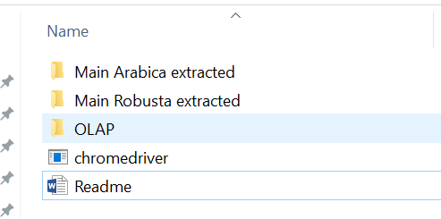

* Main Arabica extracted folder:
  + to all CSV extracted from website in Arabica section
  + to create a consolidated file called *df_Arabica_Detail*
  + to Python code for data extraction called *getData_Arabica.py*
  + to Python code for consolidation step called *process_table_Arabica.py*
* Main Robusta extracted folder:
  + to all CSV extracted from website in Robusta section
  + to create a consolidated file called *df_Robusta_Detail*
  + to Python code for data extraction called *getData_Robusta.py*
  + to Python code for consolidation step called *process_table_Robusta.py*
* OLAP folder:
  + to Analysis Services (SSAS solution)
  + to ETL Experian Coffee (SSIS solution)
  + to CSV files with data after data transformation
  + to Power BI file with the data transformation steps
  + to DDL for tables creation called *ExperianCoffee_DDL.sql*
  + to testing data after ETL data loading
* *chromedriver.exe*
* *Readme file*

**Setup tools:**

1. Download the Chrome WebDriver

<https://chromedriver.chromium.org/>

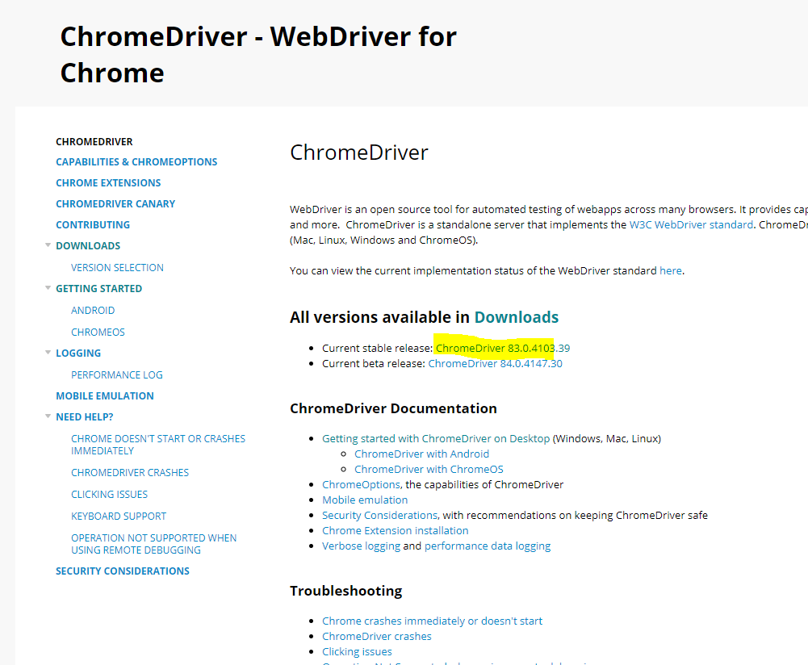

1. Copy the .exe file to the local folder

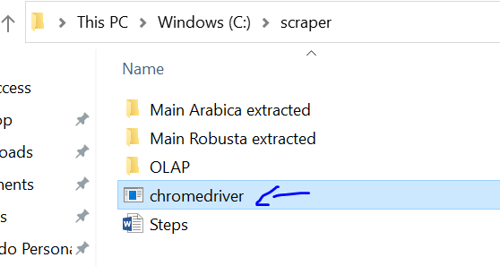

1. Download and install **Sublime** **text** app to work with Python.

<https://www.sublimetext.com/>

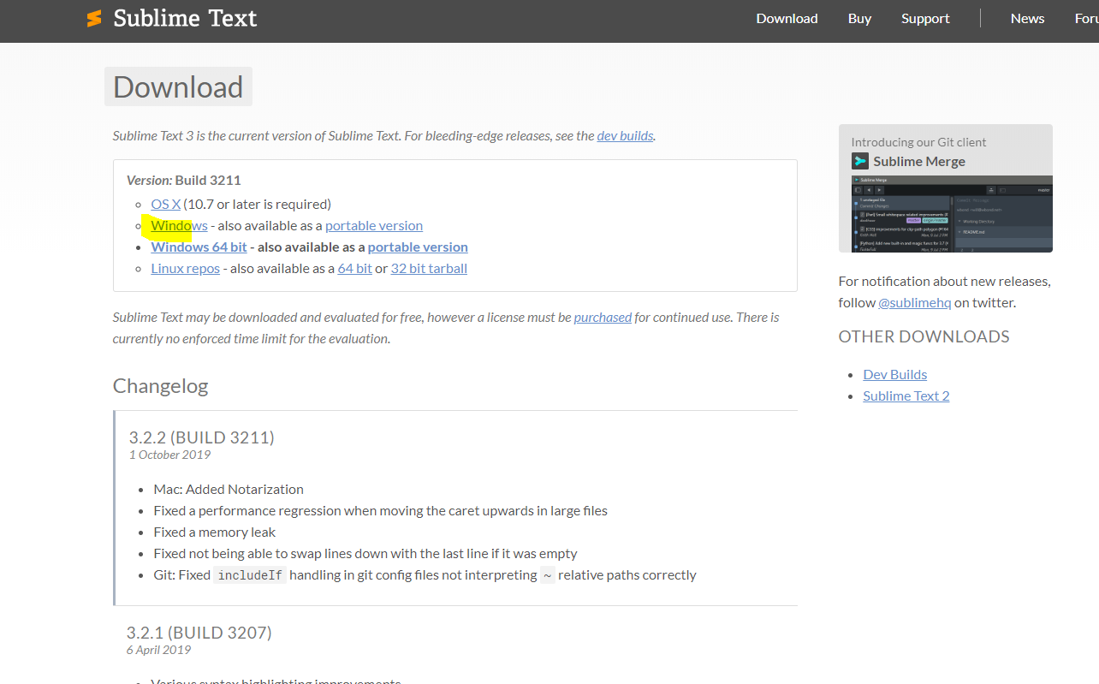

1. In CMD Install:

* **pip install selenium**

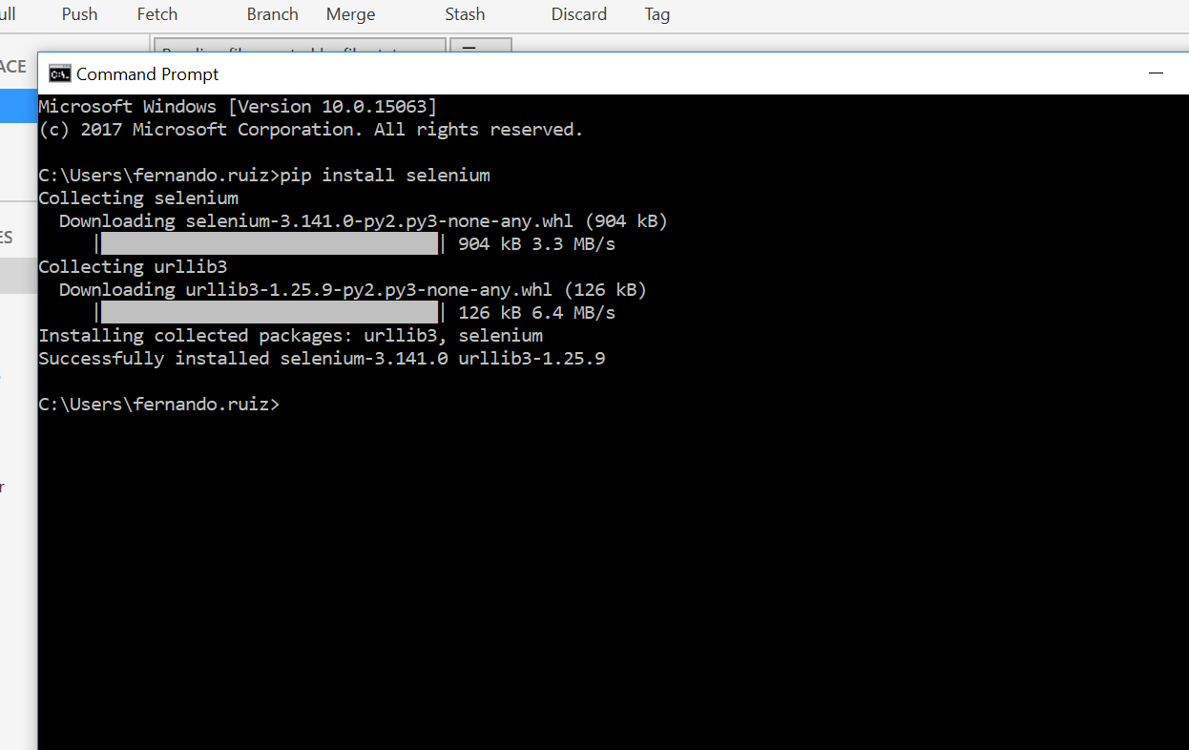

* **pip install beautifulsoup4**

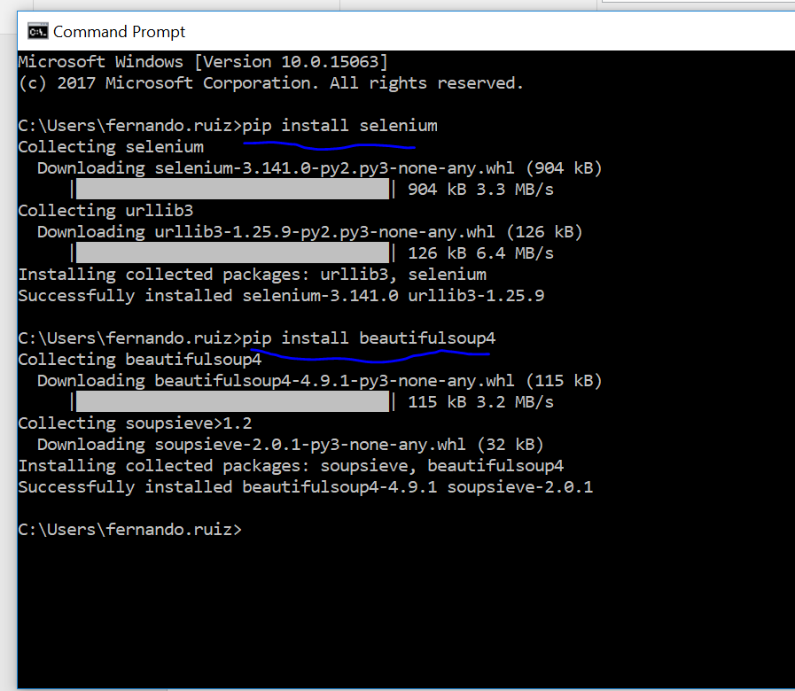

* **pip install pandas**

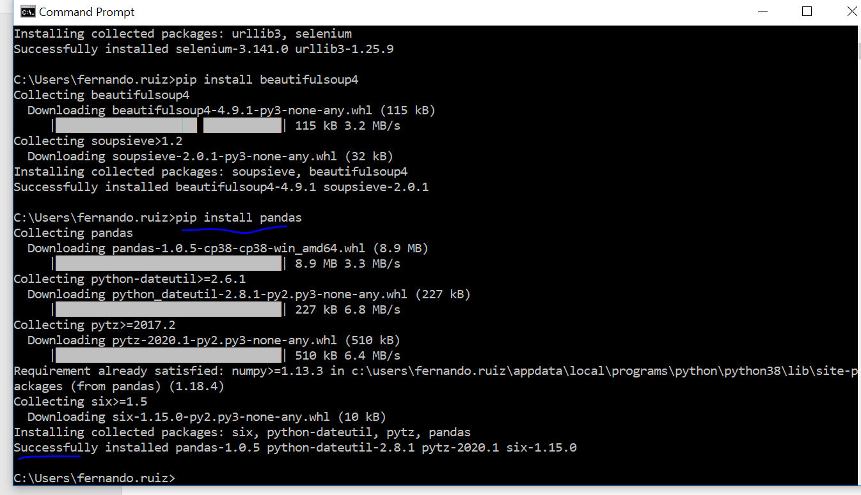

* **pip3 install lxml**

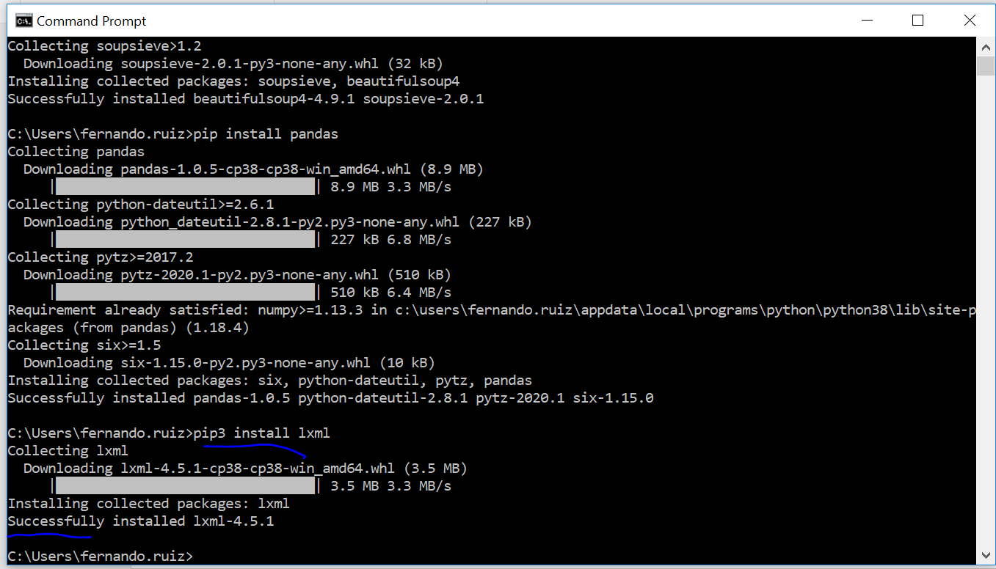

**Extract and consolidate data from website:**

1. Go to the *Main Arabica extracted* folder and run the Python code in Sublime called “*getData_Arabica.py*”

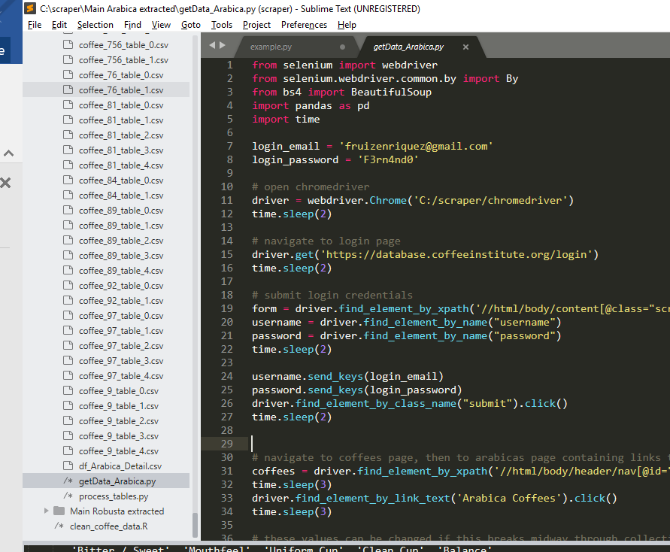

**Note before to run:**

* Add user login and password
* Update the number of cells according total rows per page. For instance, cells = **400**
* Tools > Build System > Python
* Tools > Build

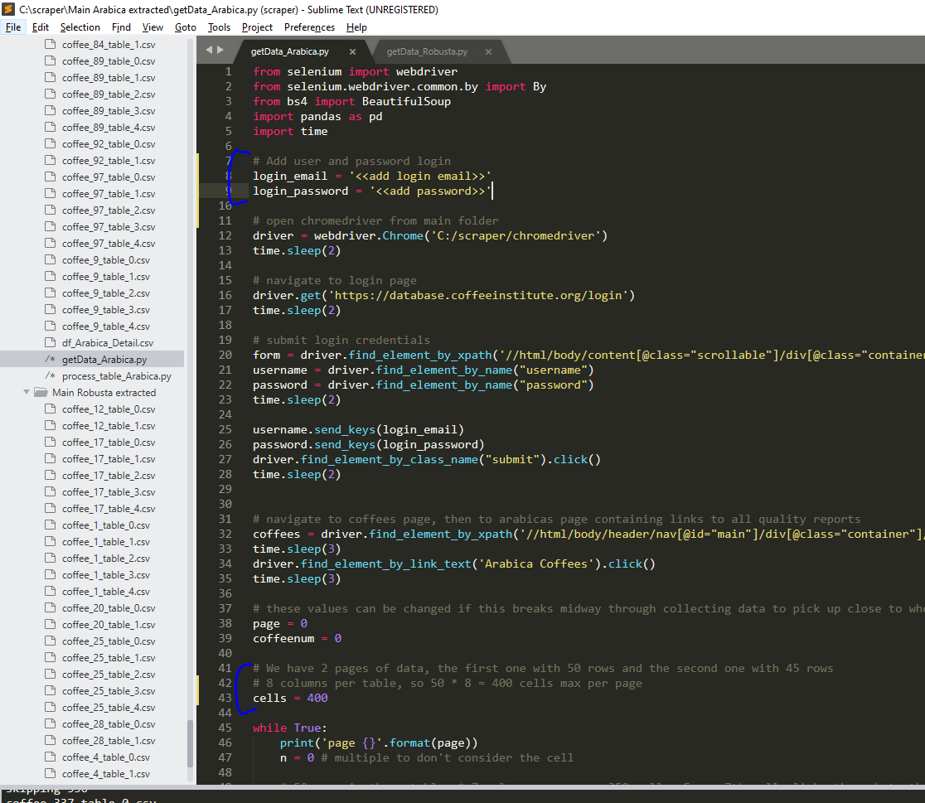

**Note**: it takes approximately 40 min to be ready.

Then to consolidate the files:

* Open the Python code called “*process_table_Arabica.py*”
* Run the code Tools > Build
* Will get the Arabica dataframe called “*df_Arabica_Detail.csv*”.

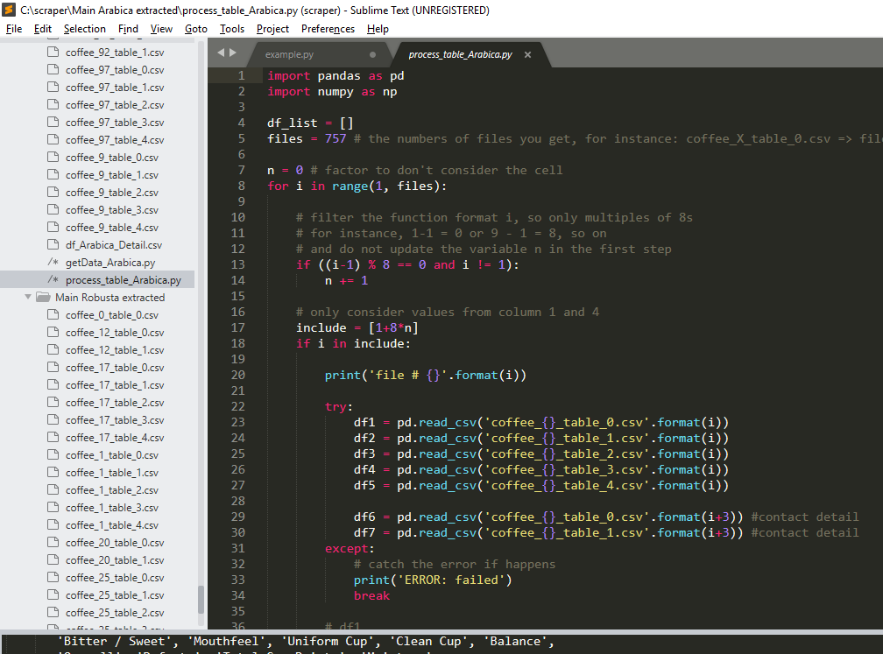

**Note**: it takes approximately 1 min to be ready.

**TO DO:**

The files coffee_481_table_3 and coffee_481_table_4 comes duplicate due to an issue in the webpage where the tables are split.

**Manually fix the issue:**

* Remove the *coffee_481_table_4* file
* Rename the file *coffee_481_table_5* as *coffee_481_table_4*
* Repeat the same step for the file *coffee_721_table_4*
* Run again

1. Repeat the same steps from **point 5** for Robusta in the “*Main Robusta extracted*” folder

* run the Python code called “*getData_Robusta.py*”
* run the Python code called “*process_table_Robusta.py*”
* We will get the Robusta dataframe called “*df_Robusta_Detail.csv*”.

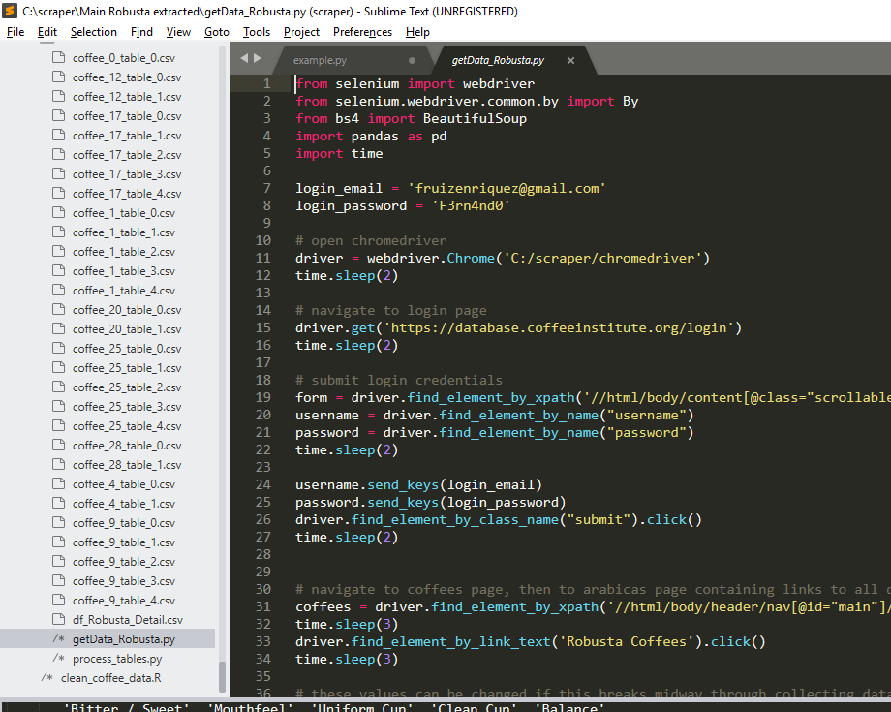

**Data cleaning:**

1. Working in Power BI to clean/transform the data

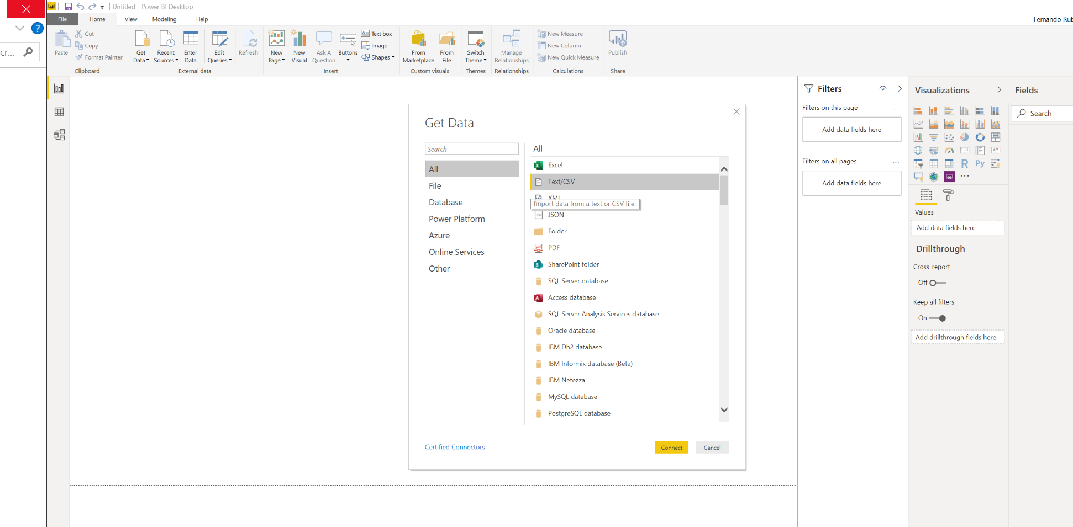

When import make sure to choose File Origin **Unicode UTF-8** to allow Power BI recognize Asian and Arabic characters, like *Japanese* language.

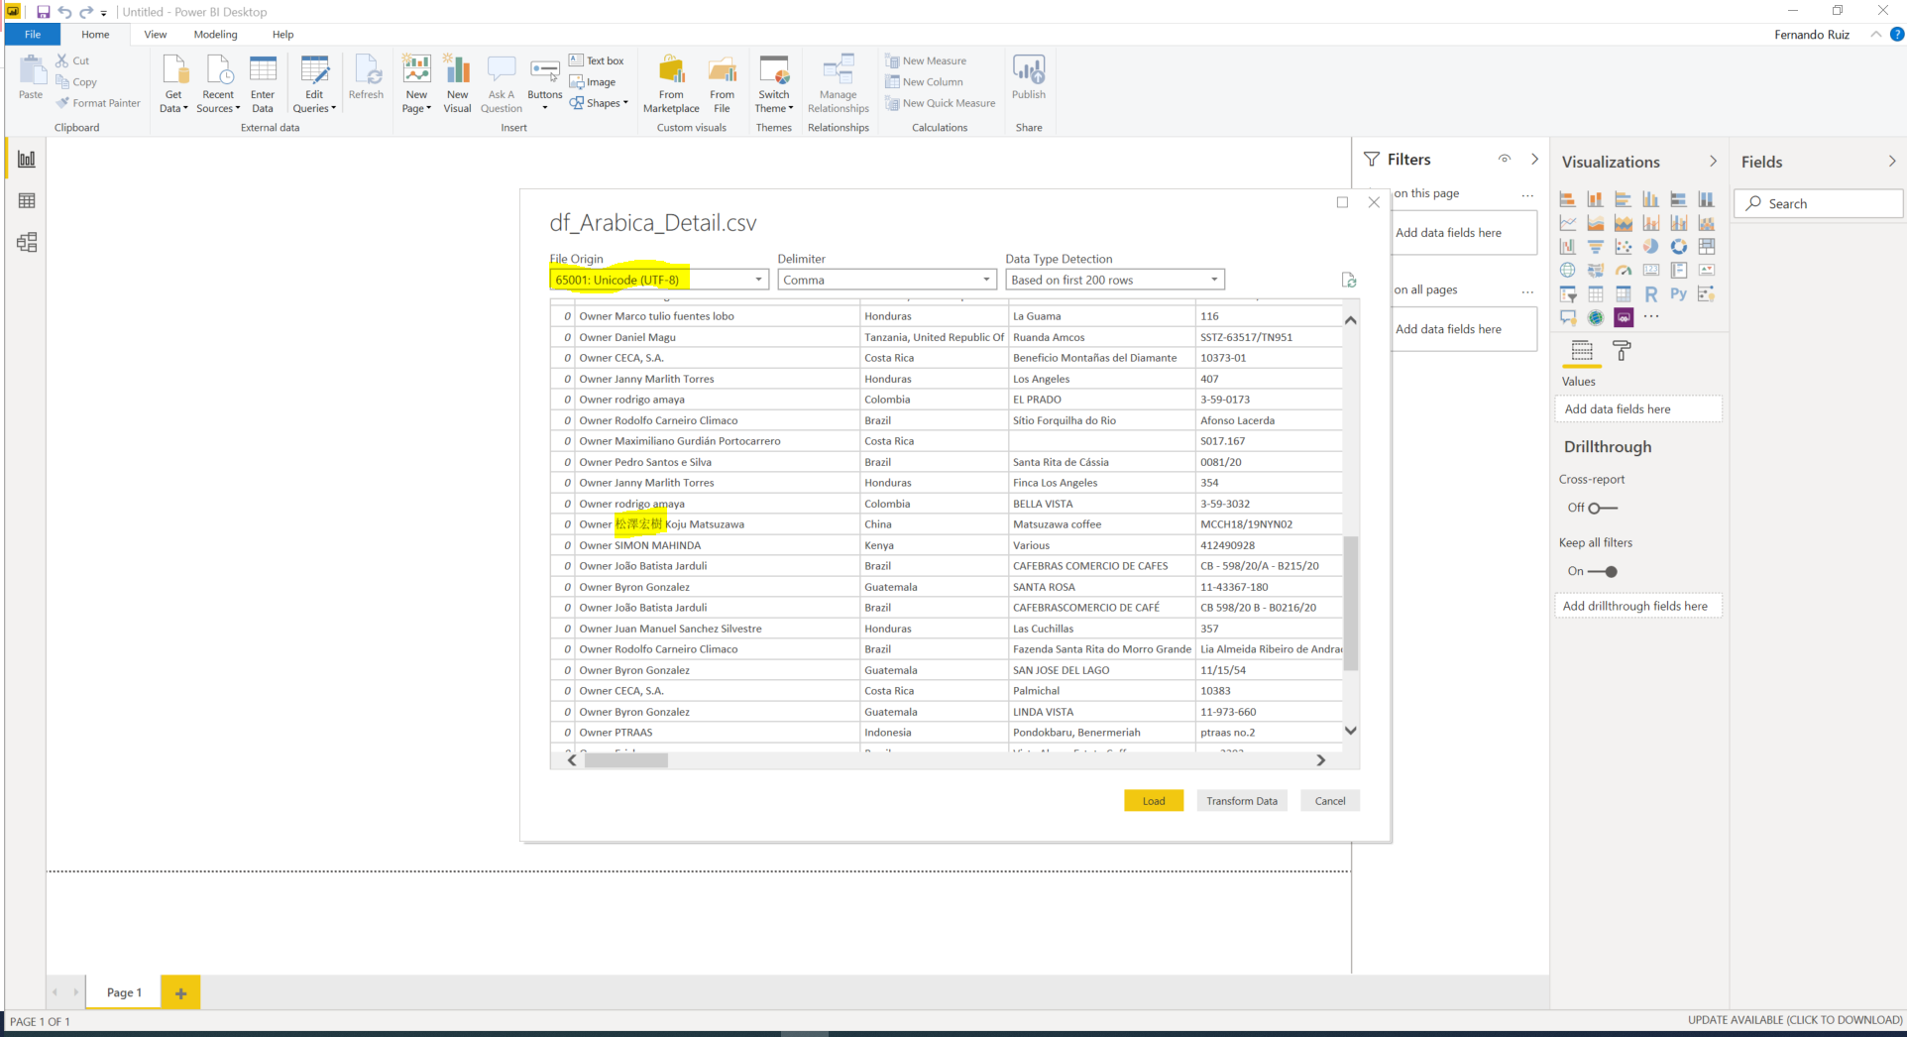

* FactSample

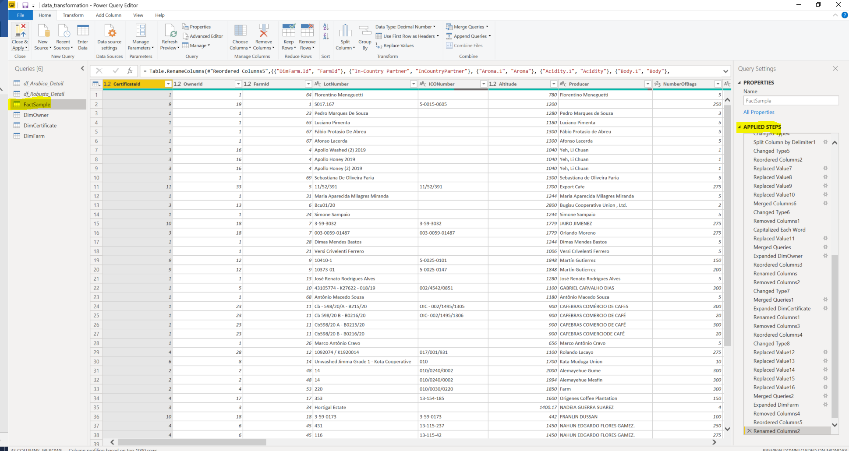

* DimOwner

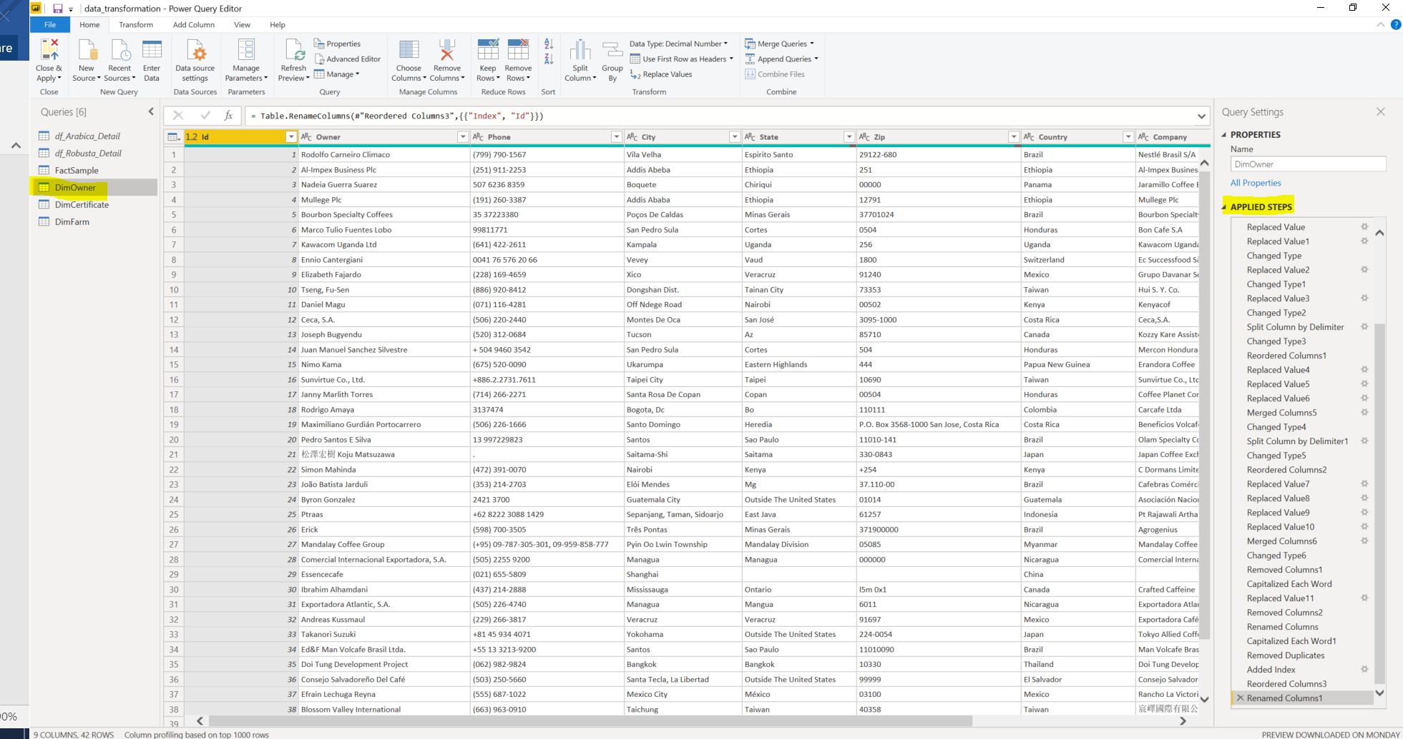

* DimCertificate

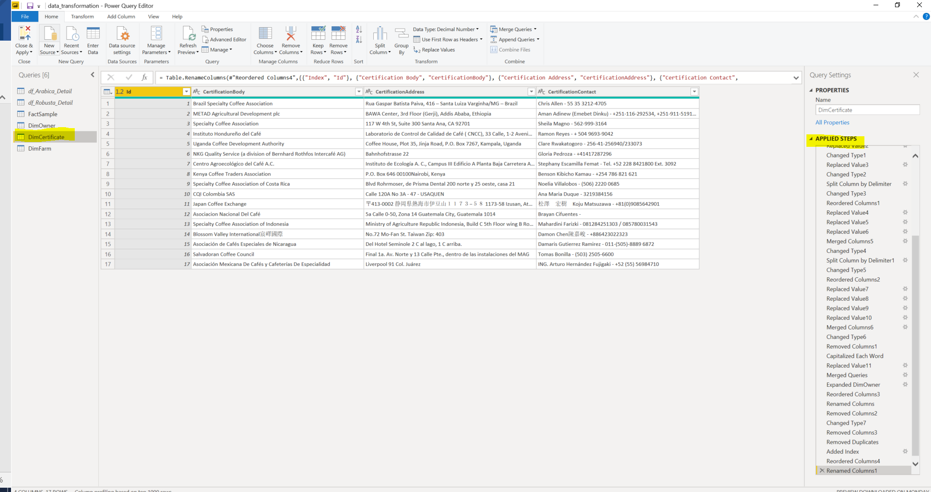

* Diagram DB

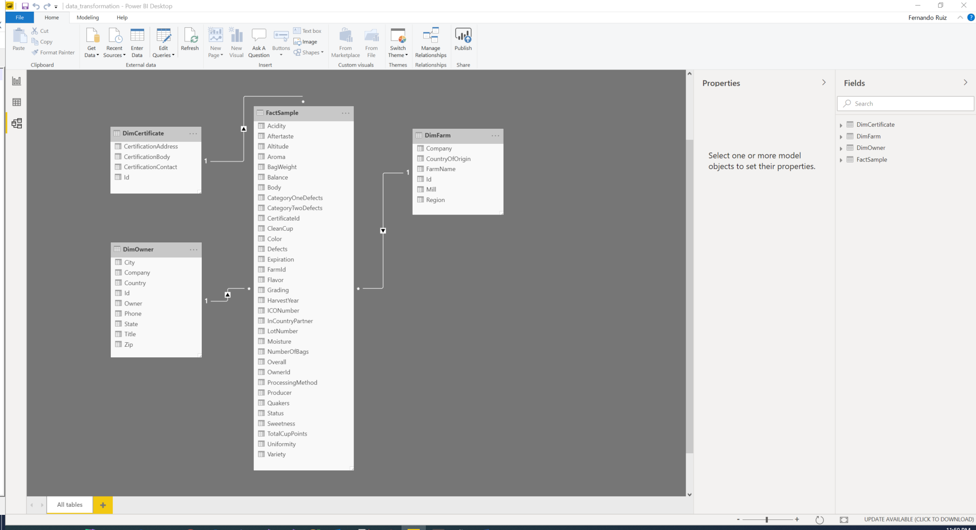

1. Export the information using DAX STUDIO

* Update the configuration

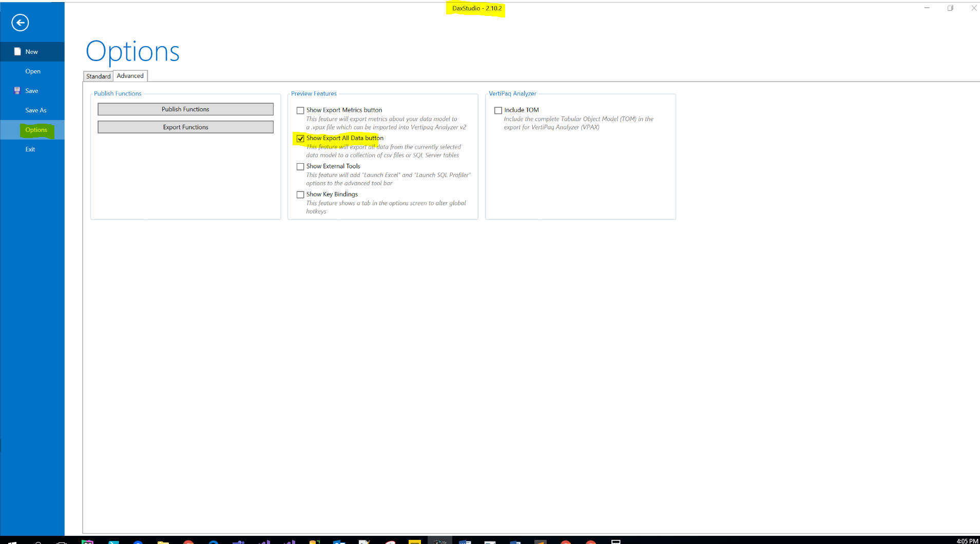

* Select the data model worked on Power BI in the previous step.

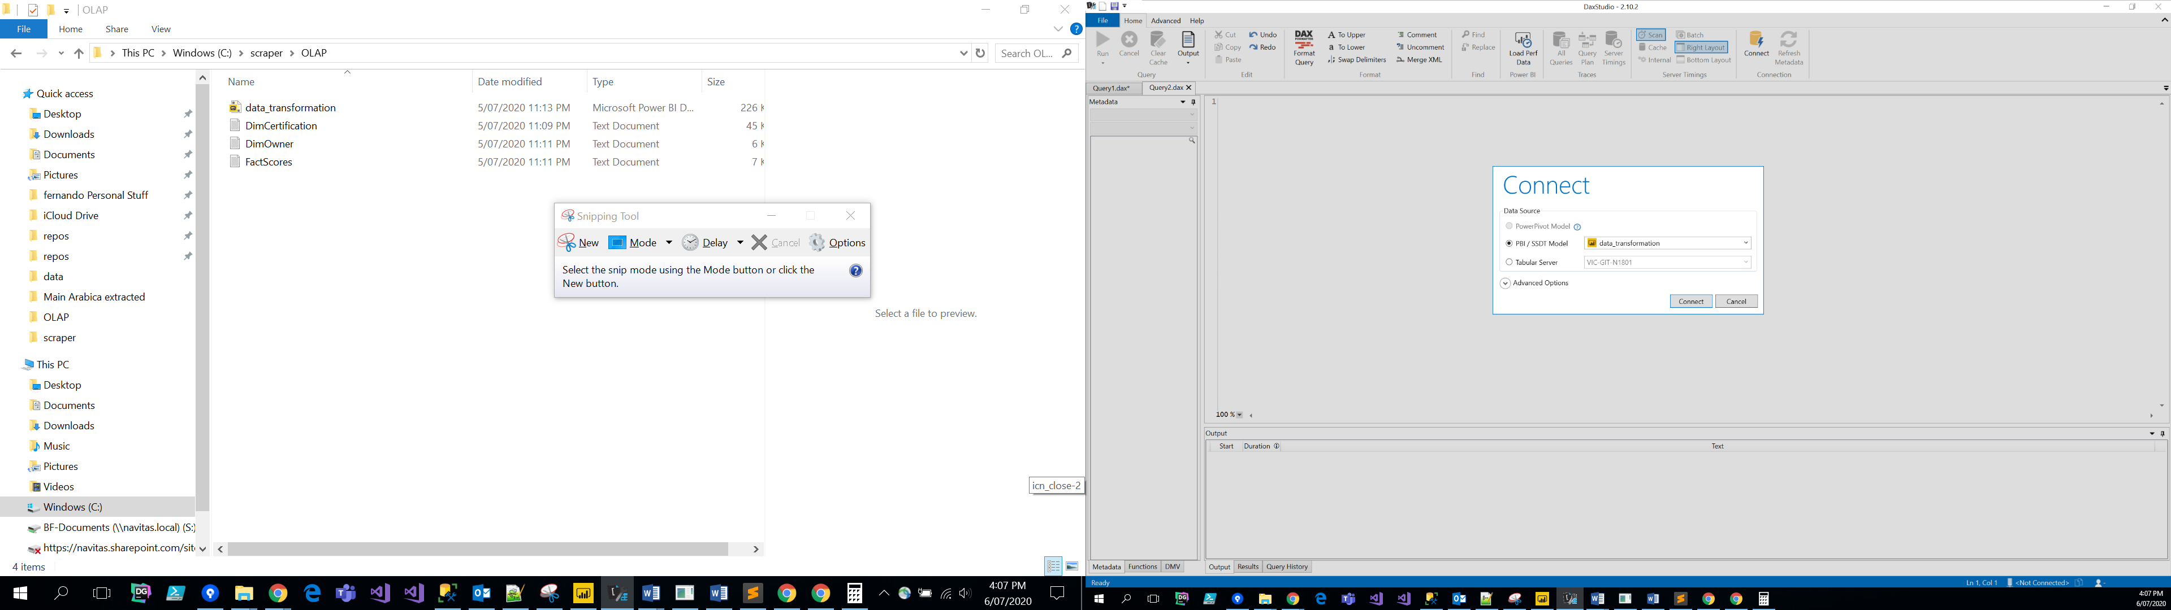

1. Export data

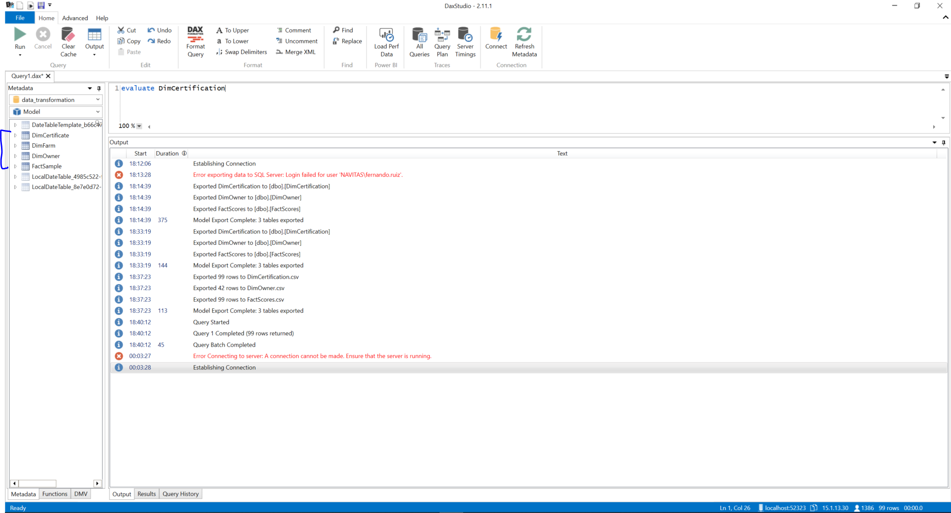

* Select CSV files

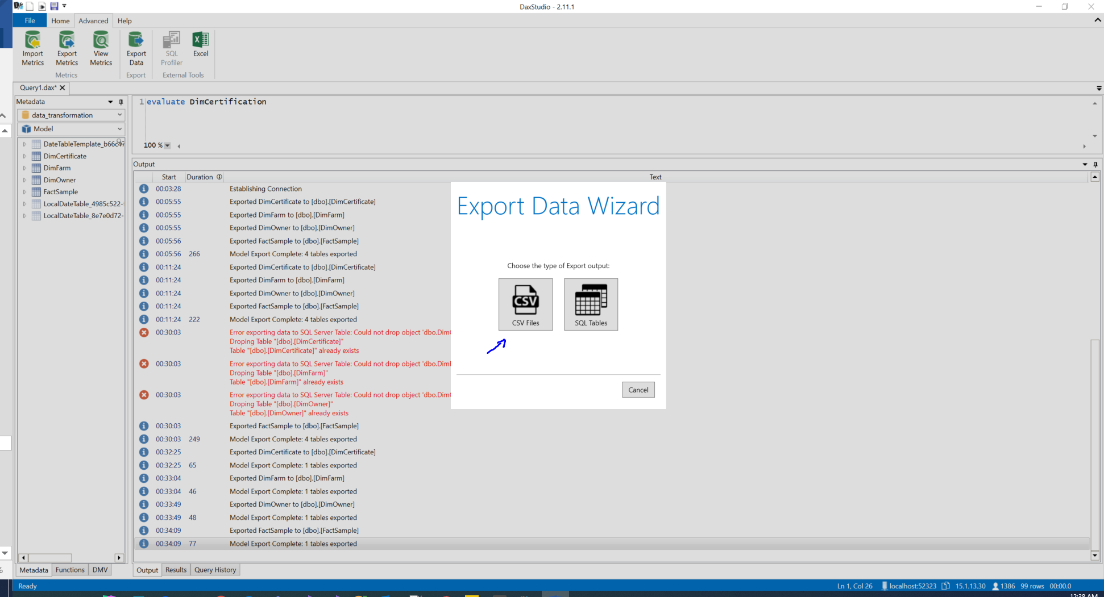

* Select the location and tables to be exported.
  + Location: \OLAP

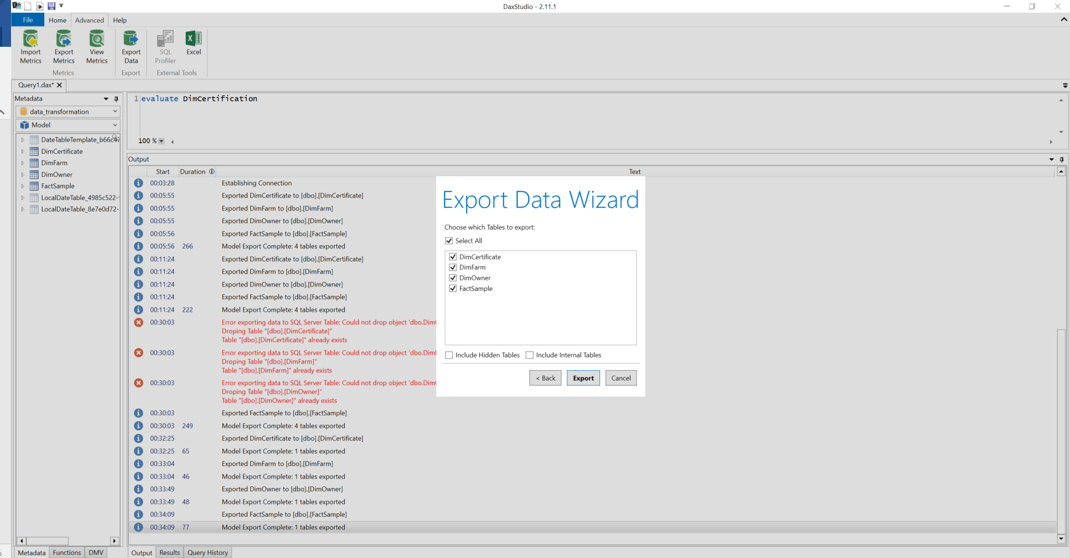

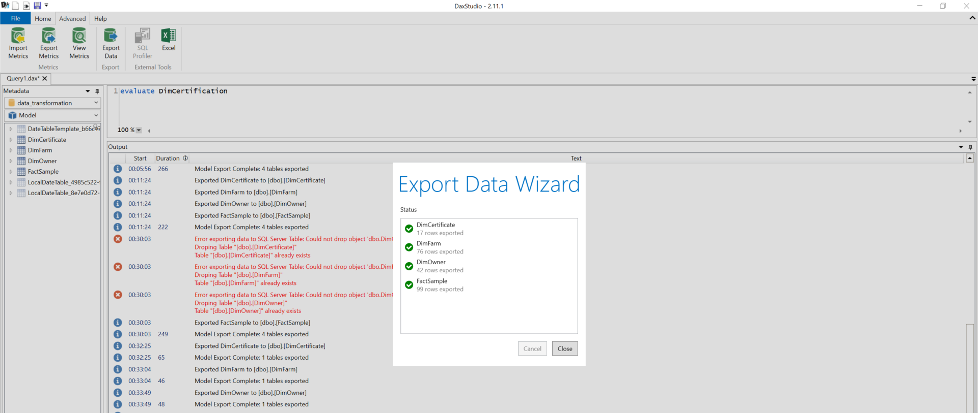

* Create DB in SQL, for this topic was called **DBExperianCoffee**

Note: SQL Server name is VIC-GIT-N1801\MSSQLSERVER03

* Run here the “*ExperianCoffee_DDL.sql*” script to create tables and FKs constraints

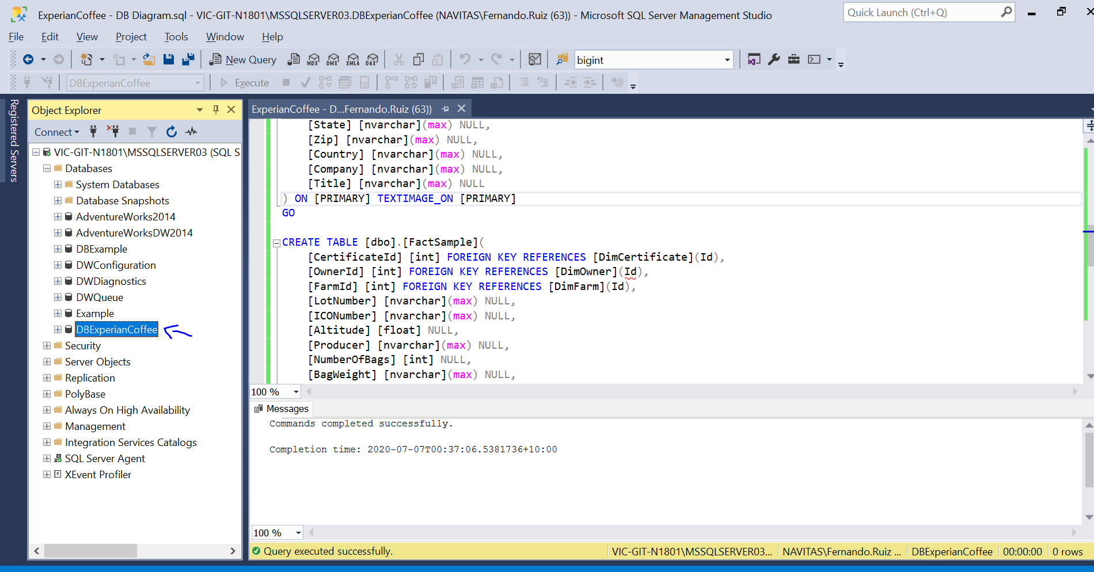

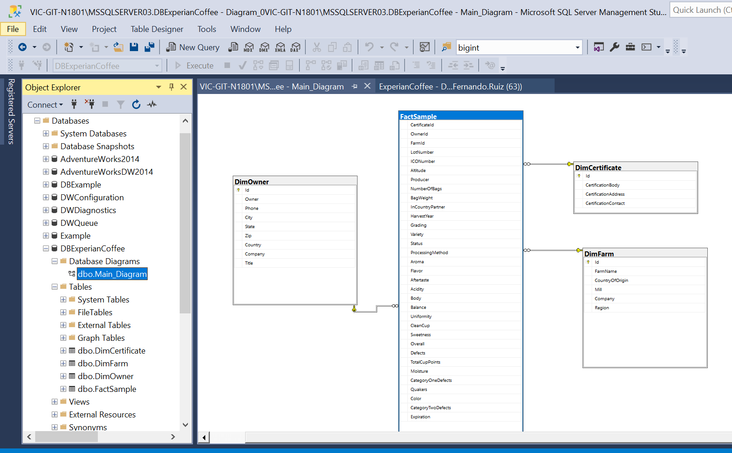

Note: SQL connection

**Server=VIC-GIT-N1801\MSSQLSERVER03;Database=DBExperianCoffee;Trusted_Connection=True;**

**Load the data by SSIS:**

1. Open the solution located in \OLAP\etl_ExperianCoffee

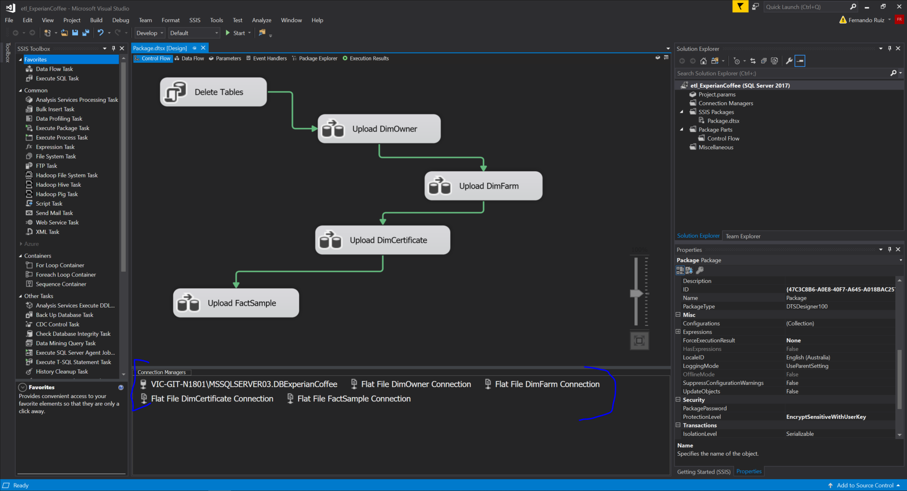

The OLEDB connection should point our local DB

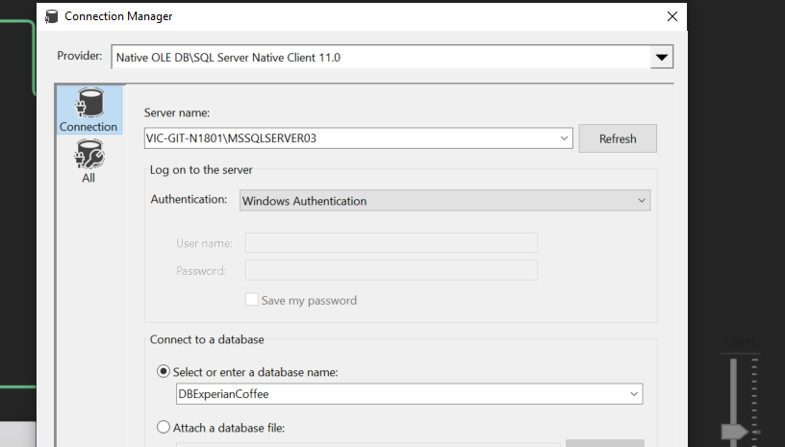

The FLATFILE connection should point the CVS files from \OLAP folder

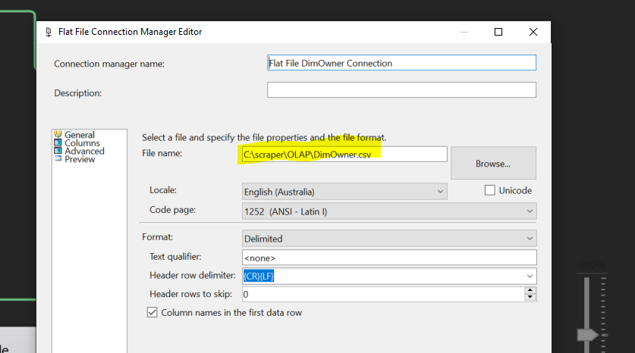

Run the package

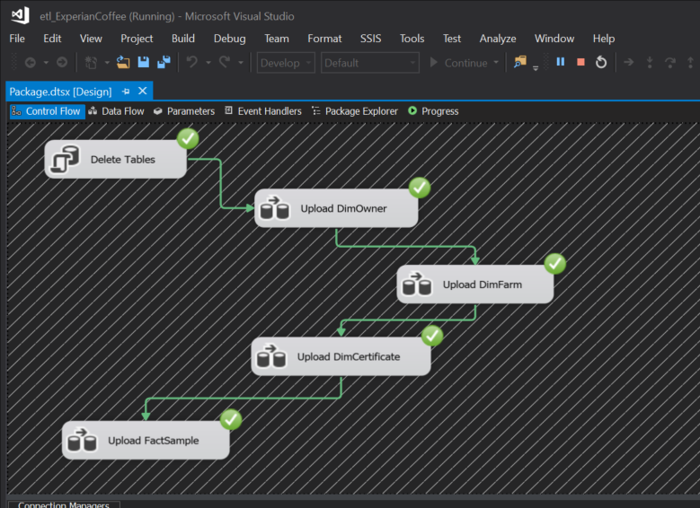

Test the data in SSMS running the “*Testing_Data.sql*” script

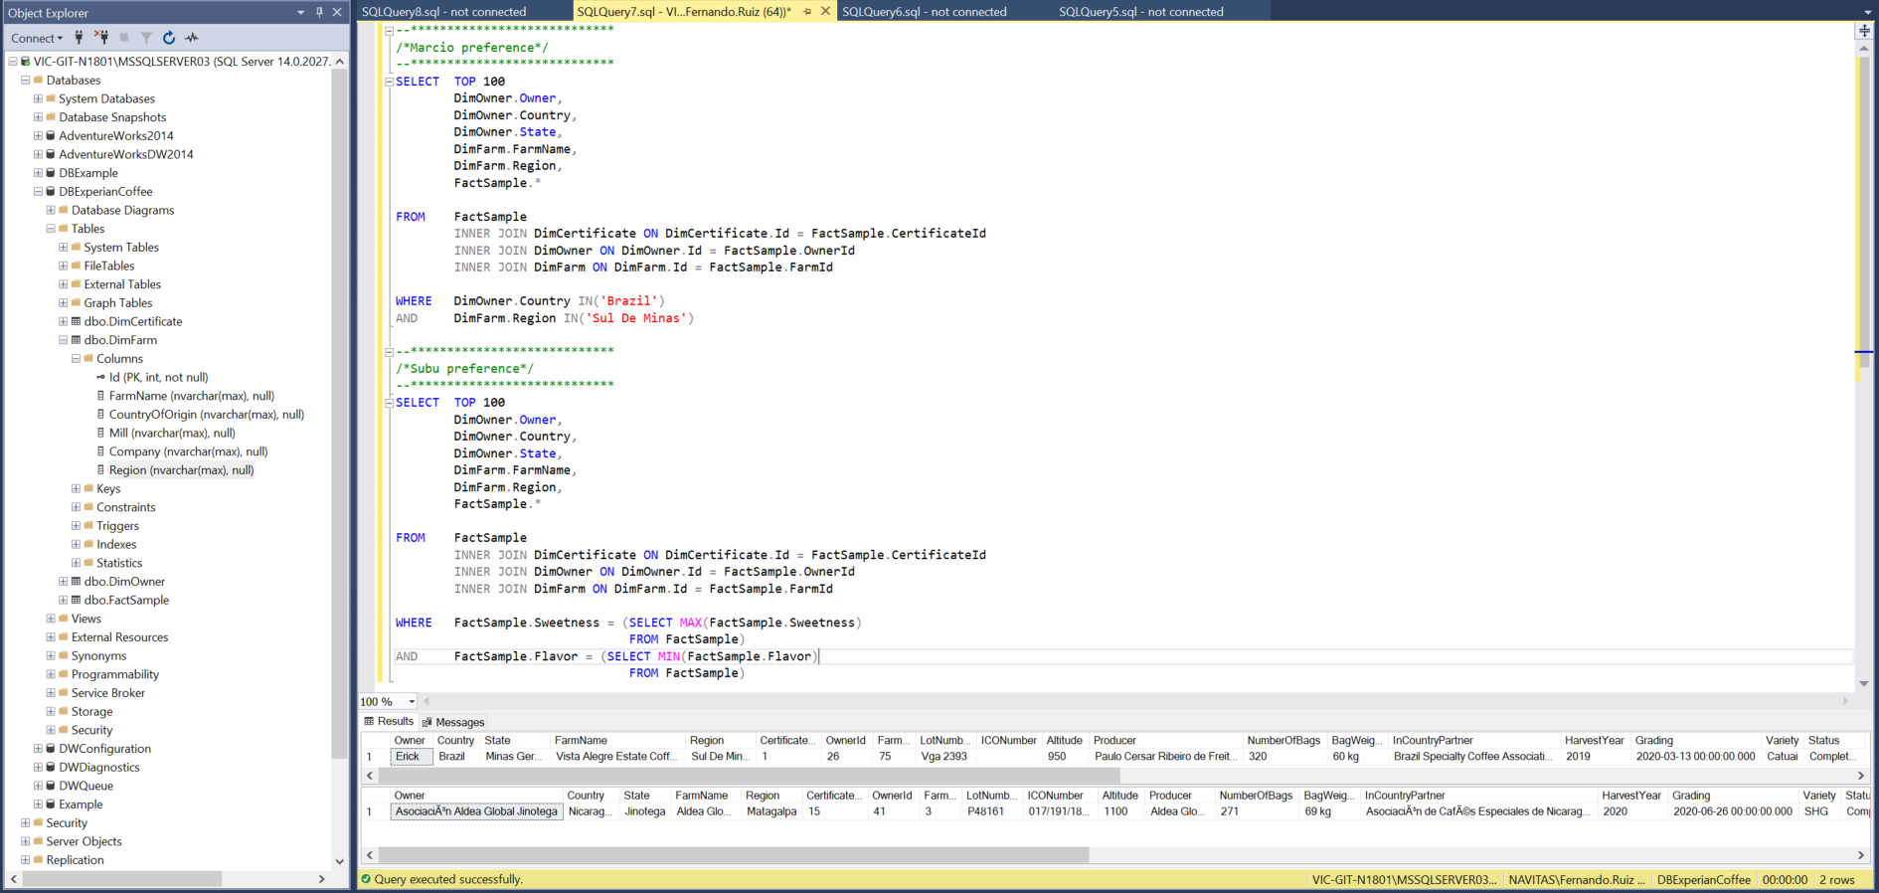

**Note:**

Investigate why the special characters like Asian symbols are not loading right by the ETL process. Using Unicode DT_WSTR but still the issue persist.

**Analysis Services by SSAS**

1. Open the SSAS file *as_ExperianCoffe* and add in property the target multidimensional mode server: VIC-GIT-N1801

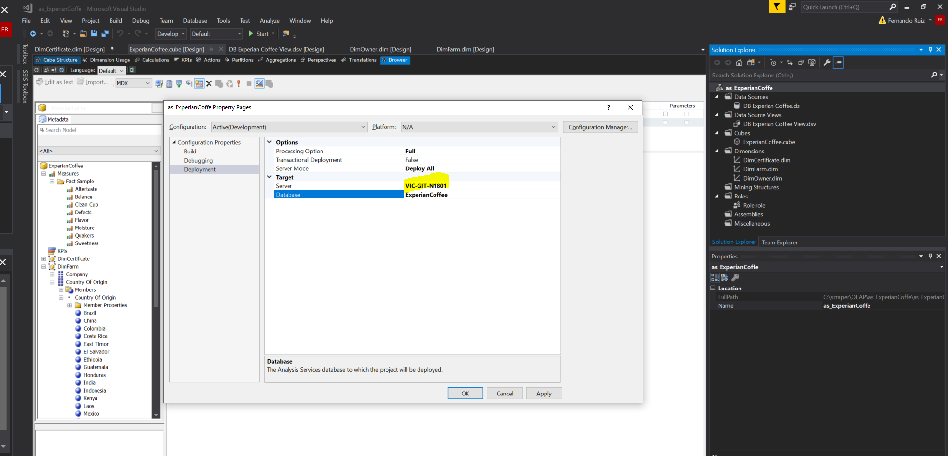

The multidimensional service mode has been created in a

